Requirements and Design Document

-Varsha Reddy Sripathi

# Project overview:

“Artsy Minds” is an application where people interested in art and craft can look for related events that happen in and around the city. The main aim of the application is to create a platform for people to find meetups. Users can check out various groups that are present and look at the connections section for available events. Users can login and signup into the application to use it. Unregistered users can sign up and become registered users but filling a form and entering their details. Both unregistered and registered users can look at the available connections, but only registered users can rsvp to the events and create new connections. They can also update or delete connections from their saved connections.

# SITE MAP:

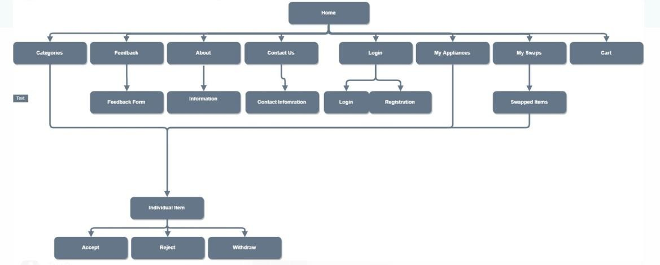

**Page Design**

## Home

* Name of the page: index.ejs
* Purpose of the page: This is the main page of the application from which users can navigate to other pages by clicking on different buttons.
* Audience of the page: Both registered users and unregistered users have access to this page.
* It has a navigation bar and general navigation bar with links that navigate to Categories, About and Contact Us pages on the site navigation bar and Sign in,My appliances and my swap and cart items links on the general navigation bar.
* All the elements on the site navigation and general navigation bar will navigate to Respective pages when clicked.

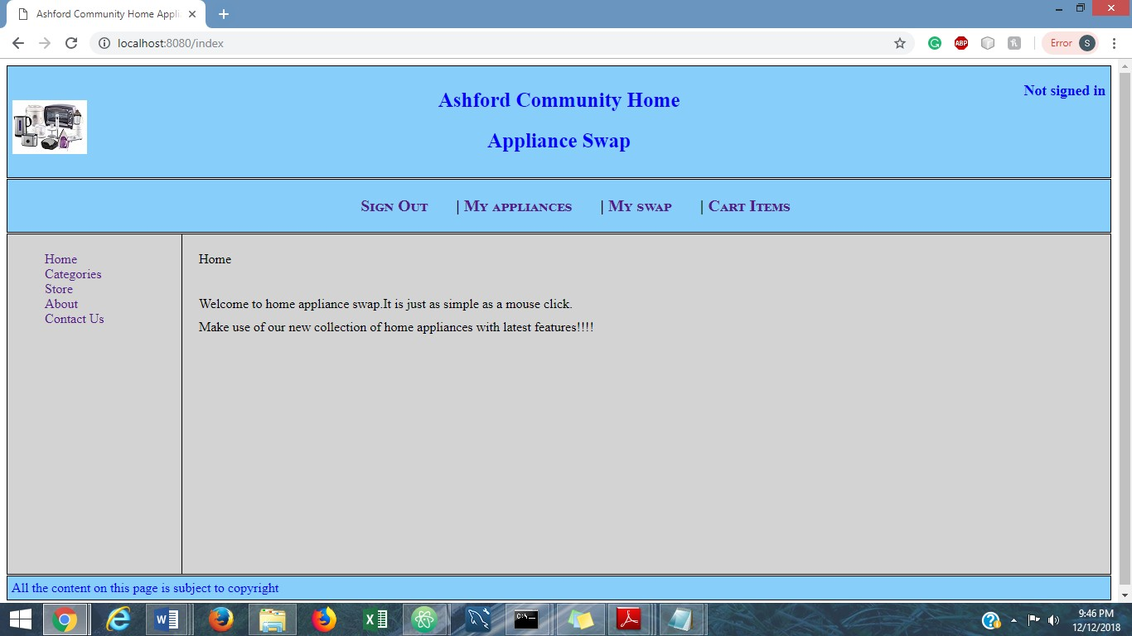

## Categories

* Name of the page: categories.ejs
* Purpose of the page: When the user is not signed in the page displays all the categories and the items under each category.When the user is signed in only the items which the user is not associated with will be displayed.
* Audience of the page: Both registered and unregistered users can access the page. However the content is different for them.
* All the categories and corresponding items belonging to each category are displayed based on the user who is logged in .The functionality is developed using sessions.
* HyperLinks: Hyperlink for each item present on the page will navigate to the page specific to that item.

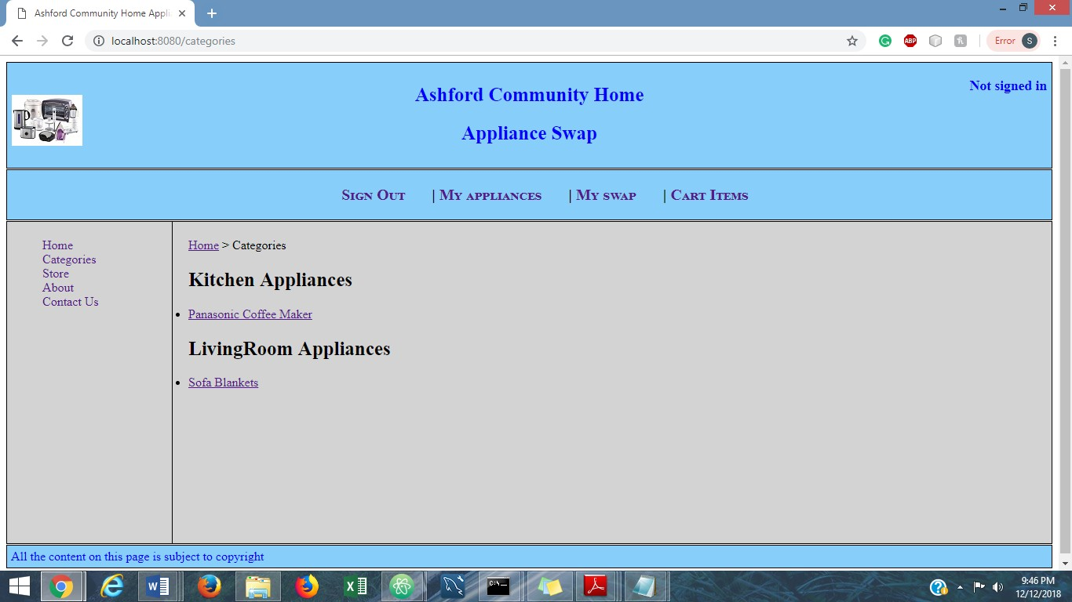

## About

* Name of the page: about.ejs
* Purpose of the page: About page describes a bit about the application.
* Audience of the page:Both registered and unregistered users can access this page who wish to know about the website.
* It has a site navigation bar and general navigation bar with links that navigate to Categories, About and Contact Us pages on the site navigation bar and Sign in,My appliances and my swap and cart items links on the general navigation bar.
* All the elements on the site navigation and general navigation bar will navigate to respective pages when clicked.

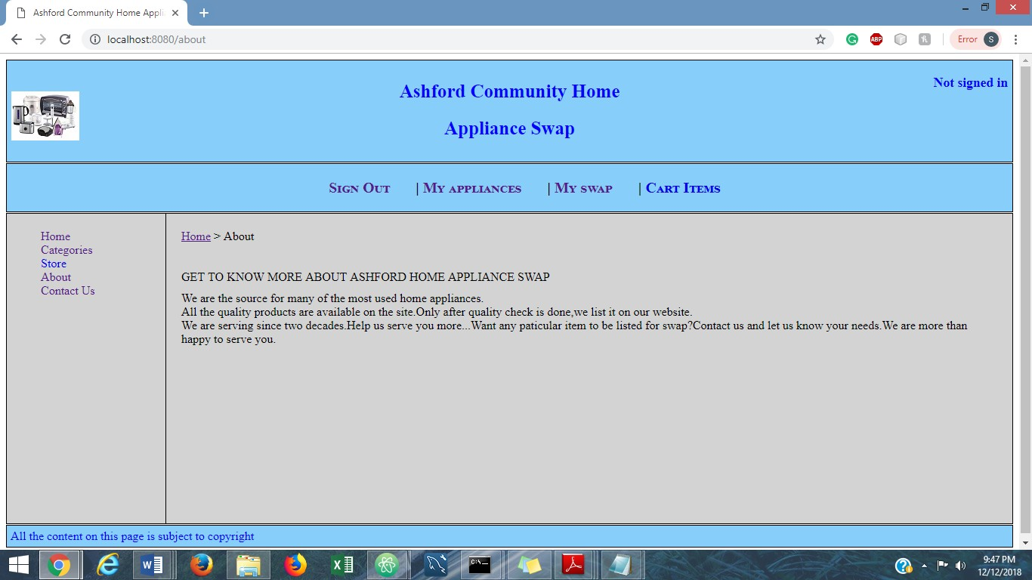

## Contact Us

* Name of the page: contact.ejs
* Purpose of the page: Contact page gives the contact information about application and a form for the users to fill in to be contacted later.
* Audience of the page: Both registered and unregistered users can access this page who wish to contact the website.
* It has a site navigation bar and general navigation bar with links that navigate to Categories, About and Contact Us pages on the site navigation bar and Sign in,My appliances and my swap and cart items links on the general navigation bar.
* All the elements on the site navigation and general navigation bar will navigate to respective pages when clicked.

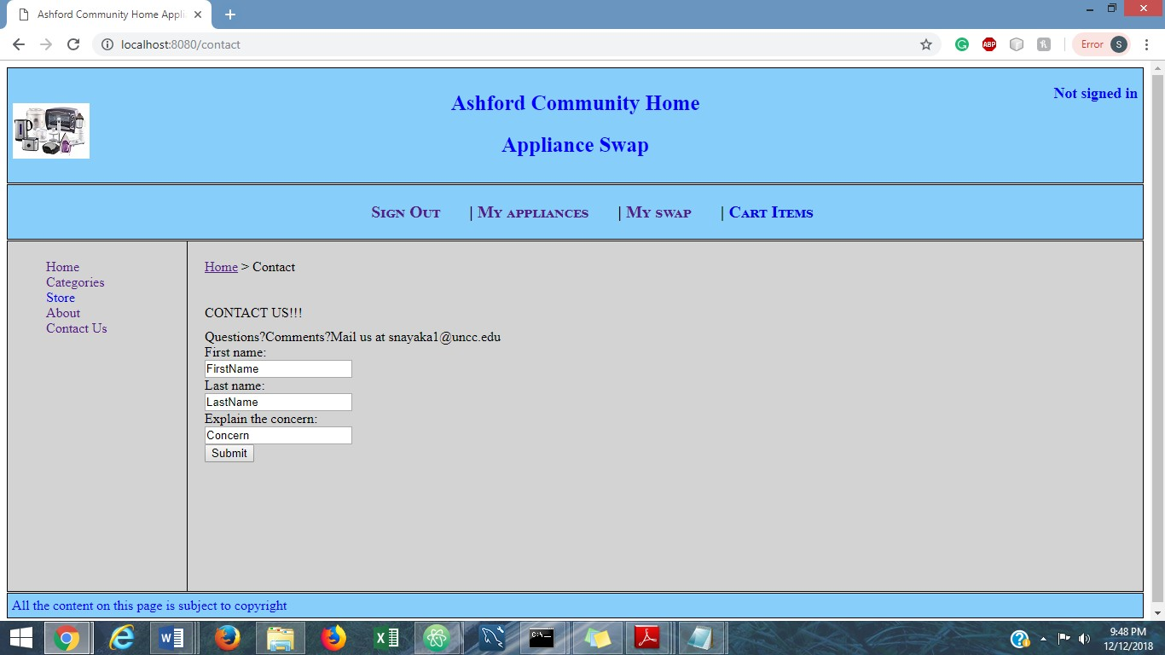

## Login

* Name of the page: login.ejs
* Purpose of the page:The page is for the registered users to be able to login.
* Audience of the page:Registered users can login from this page and unregistered users can navigate to register page from this page.
* UserID and password fields are present on this page.The application would match the userID and password present in User collection in database and lets the user login with his profile.
* Submit button navigates to myitems page on the application.

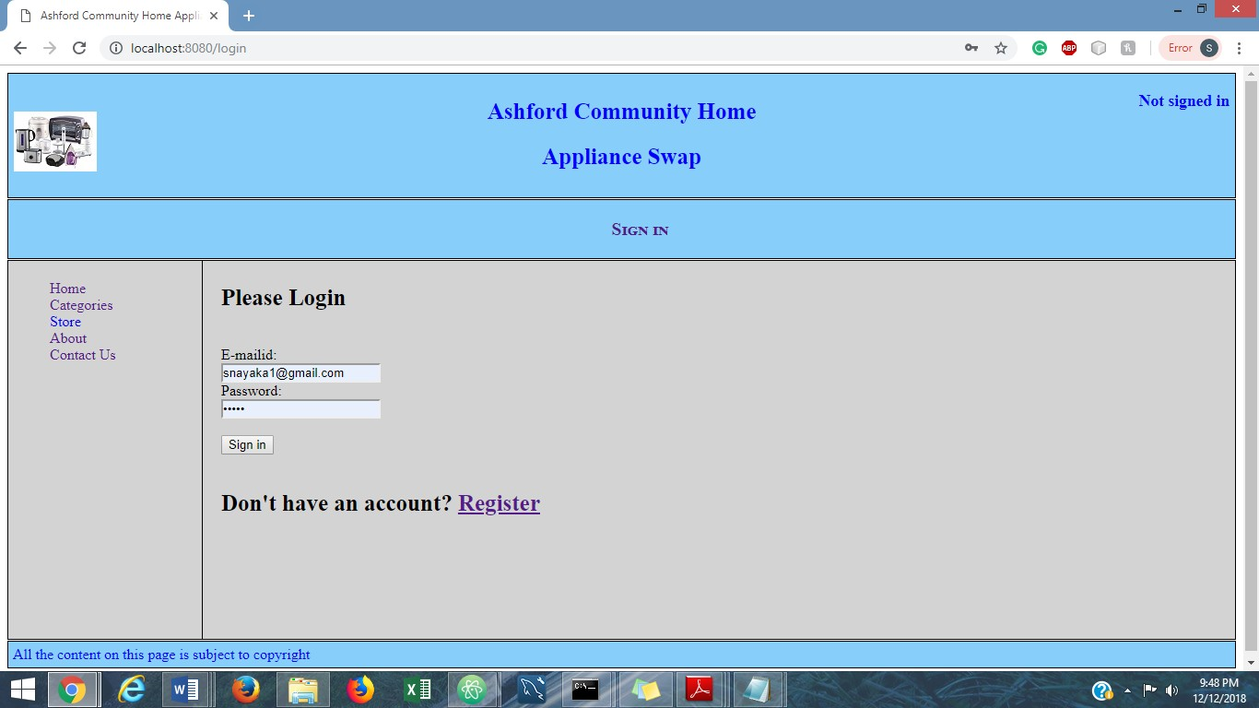

## Registration

* Name of the page: registration.ejs
* Purpose of the page: The new users can register on the application on this page.
* Audience of the page: Unregistered users are the audience for this page.
* The text fields First Name, Last Name, Username, Password and email Address needs to be filled.
* Validation: If already existing users details are entered, it would prompt that the application already exists. Only alphabets are taken in the first name and last name fields. The email field must contain @ character.
* Submit button on the Registration page would store the details in the “Users” Collection and navigates to My appliances page.

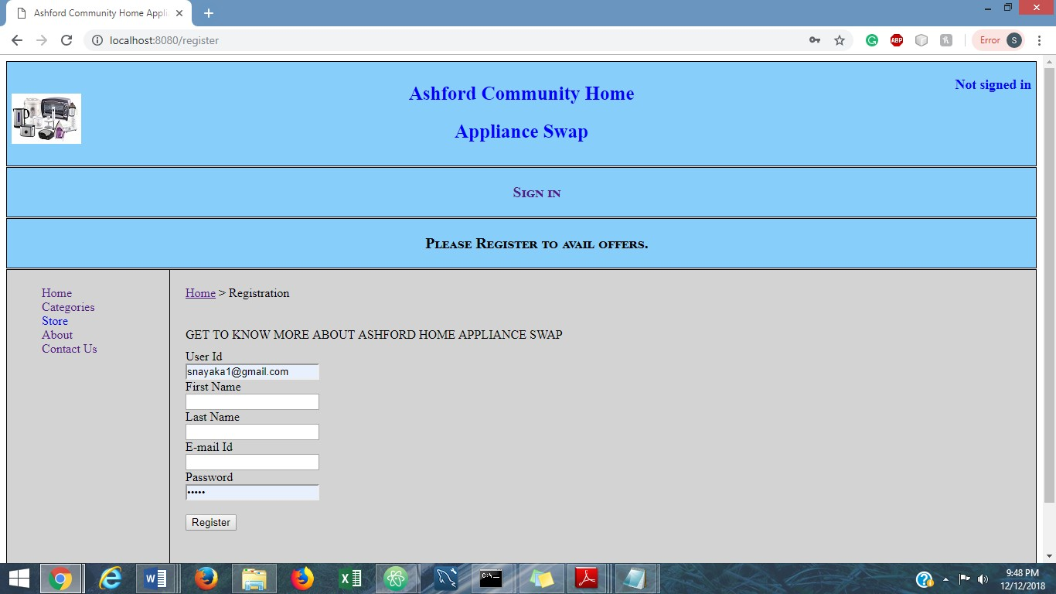

•

## My Appliances

* Name of the page: myItems.ejs
* Purpose of the page: This page has all the appliances that are swapped,pending and available to the user.The user can swap the available items.
* Audience of the page:Only registered users can access this page and who want to swap their appliances can visit this page.
* We can update or delete the appliances with Pending and available state.We can update the items that are in swapped status. When you click on update the item,you will be navigated to swap page for you to be able to swap the appliance.
* When you click on Delete button,the appliance is delete from the Useritems Collection.

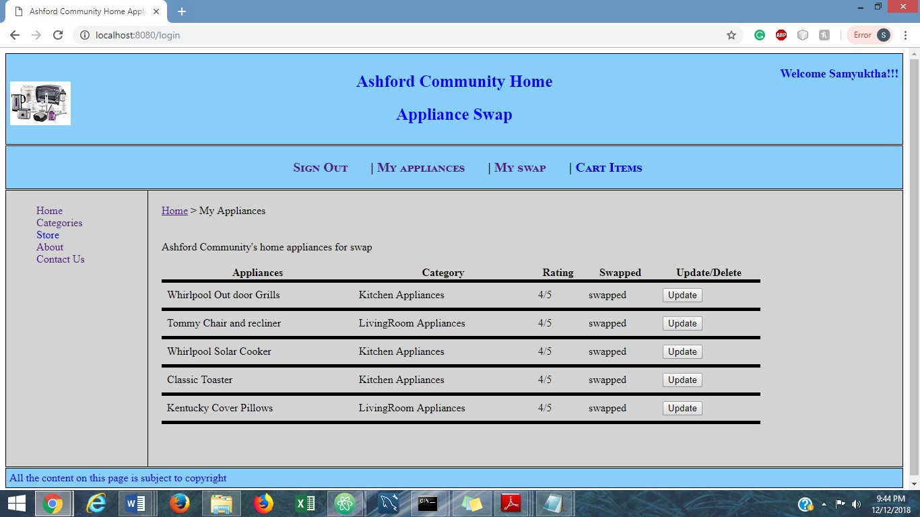

## My Swaps

* Name of the page: mySwaps.ejs
* Purpose of the page: This page displays the options to accept, reject the swap offer for the item, that is pending in status in MyAppliances page.
* Audience of the page:All the registered users.
* Accept button lets users swap the item, and the status changes to swapped in MyItems page.
* Reject/Withdraw button makes the items available from the pending state and the items are rejected for swap.

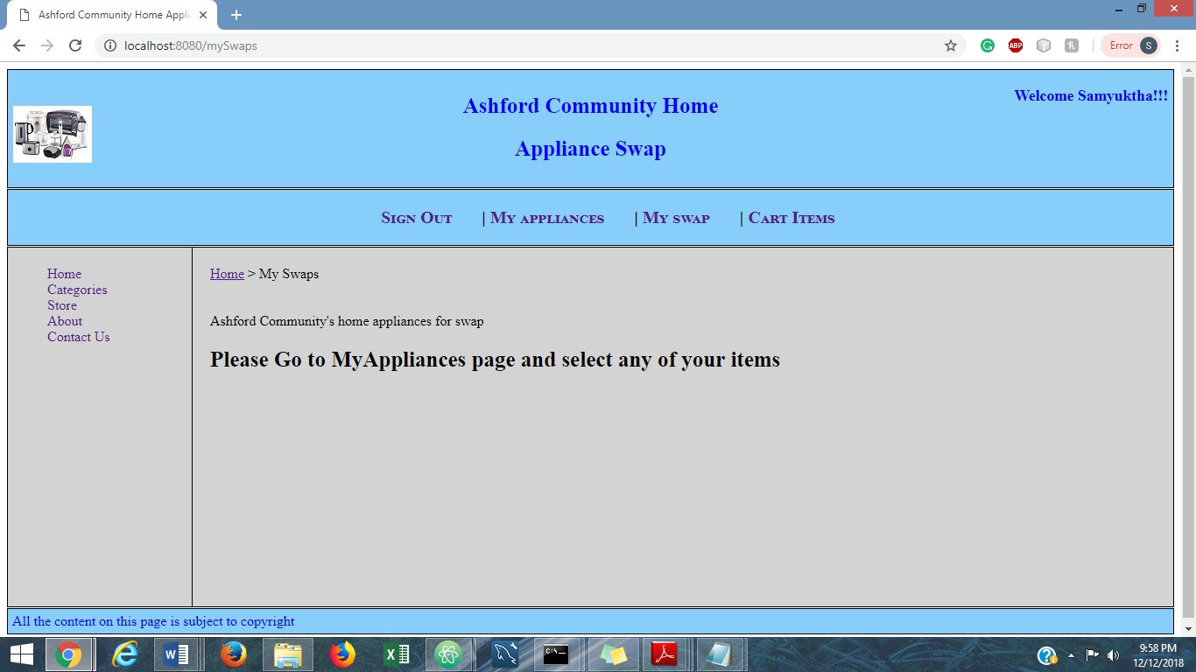

## Feedback

* Name of the page: feedback.ejs
* Purpose of the page: We can rate the appliance and the appliance owner on this page.
* Audience of the page: The person who want to offer the appliance will be navigated to this page to rate the appliance and the appliance owner.
* Data fields for rating the appliance and appliance owner would be taken and store in “offerfeedbacks” Collection.
* Submit button navigated back to my appliances page with new appliances and updated status.

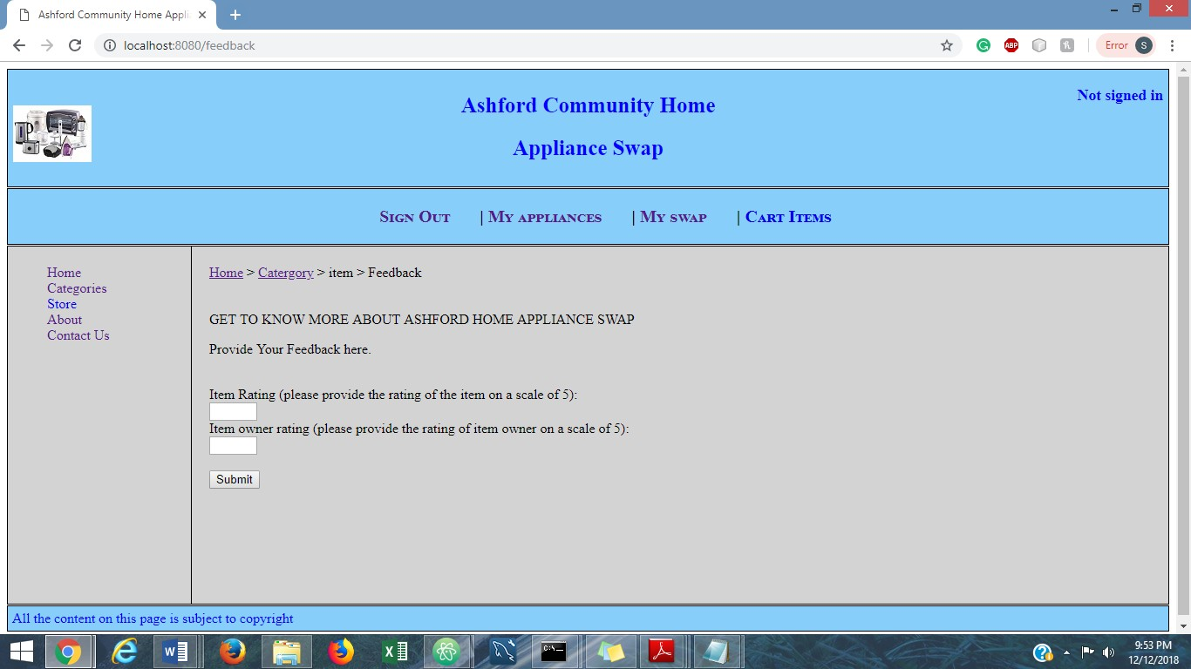

## Swap Page:

* Name of the page: swap.ejs
* Purpose of the page: We can select the item you want to swap with.
* Audience of the page: The person who want to swap an item uses this page.
* Only if the item that you want to swap is selected then the confirm swap button is enabled. This button navigates to feedback page for the user to give the ratings for the appliance and the appliance owner.

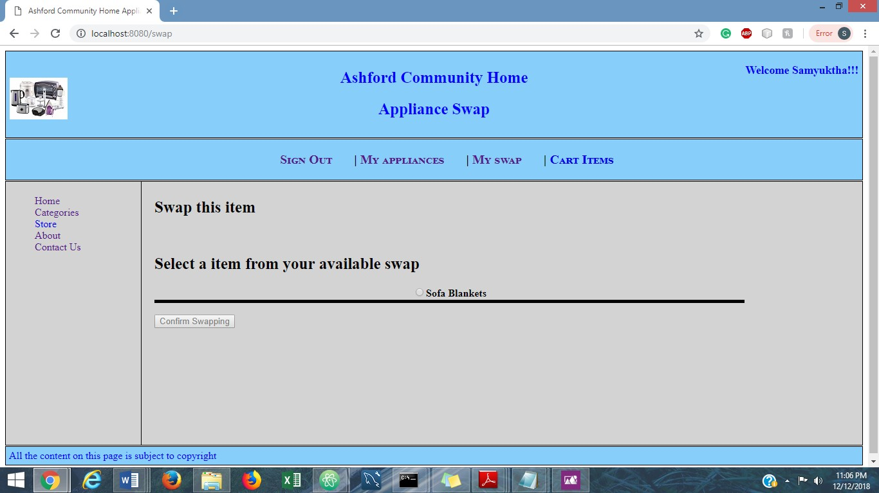

•

4) Database structure: Following are the collections in the “AshfordAppliancesSwap”:

1.UserProfiles:The useritems associated to each user are stored in this collection. 2.categories:All the categories details are present in this collection.

3.items:The details of each item along with the category it belongs to is present in this collection. 4.offerfeedbacks:The ratings for the appliance and owner of the appliance is stored here.

5.useritems:The useritems associated with each user is stored in this collection. 6.users :All the details of the users along with their Id’s and passwords.